 | Patient Health Monitoring  Technical Design Document  1.0
 |  |  | Prepared By / Last Updated By | Reviewed By | Approved By
 | Name |  | Mehroz Ahmad, Ahad Zafar,Rohit Saran, Priyanshi Srivastav, Aditya Pratap Singh | Mr. Vinay Agnihotri | Mrs. Shilpa Mahajani
 | Role |  | Team Member | Mentors | Academy Head
 | Signature
 | Date |  | 4/24/2019 | 4/24/2019 | 4/24/2019

Table of Contents

1.0 Introduction 3
1.1 Purpose of this document 3
1.2 Scope 3
1.3 Intended Audience 3
1.4 Definition & Acronyms 3
2.0 Conventions and Standards Followed 4
3.0 Assumptions, Dependencies and Risks 4
3.1 Assumptions: 4
3.2 Dependencies: 4
4.0 Schematic Diagram 4
5.0 Use Case Realization 5
5.1.1 User Registration 5
a. Functional Requirement 6
b. UI Validations 6
c. UI Controls 7
d. UI Methods Definition 8
e. UI Design 9
6.0 Database Design 10
6.1 Data Model 10
6.2 Tables Structure 10
7.0 Change Log 13

Introduction

Purpose of this document
The purpose of the detail design document is to define the detailed design for all the components of Patient Health Management system that are specified in the Business Requirement/Use case document. All the low level components, interfaces and integrations are detailed out in this document.

Scope
This sub-section shall state the scope of this detailed design document
• Create and maintain user information.
• Create and maintain patients information

Intended Audience
The intended audience for this document are
- Developers, testers, other associates in the project
- Technical lead, Scrum Master
- Product Owner

Definition & Acronyms
Acronyms | Definitions
PHMP | Patient Health Monitoring Portal

Conventions and Standards Followed
The modules under scope needs to adhere to the coding standards and guidelines

Assumptions, Dependencies and Risks

Assumptions:
- Once the application is built the PATIENT HEALTH MONITOR PORTAL will manually load the user list into the system.
- There will be no concurrent users for the application. The User will maintain the Patient profile.
- Any changes to the design mentioned in the BRD would be taken as a Change Request

Dependencies:
- Availability of database design characteristics & access shall be defined by the
- Resource availability throughout each of the sprint

Schematic Diagram
A schematic, or schematic diagram, is a representation of the elements of a system using abstract, graphic symbols rather than realistic pictures. It gives an overview of overall system
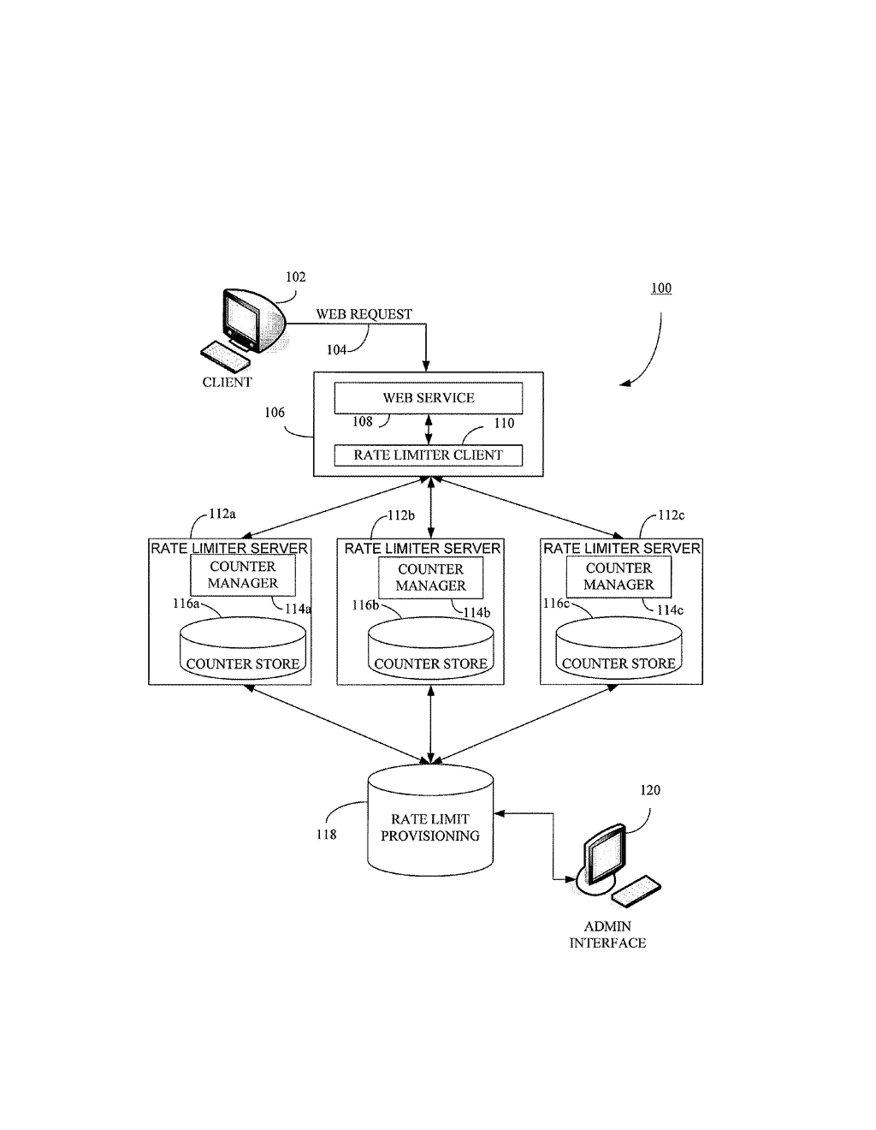
The above pic is only an example and not representational of the Patient Health project

Use Case Realization

User Registration

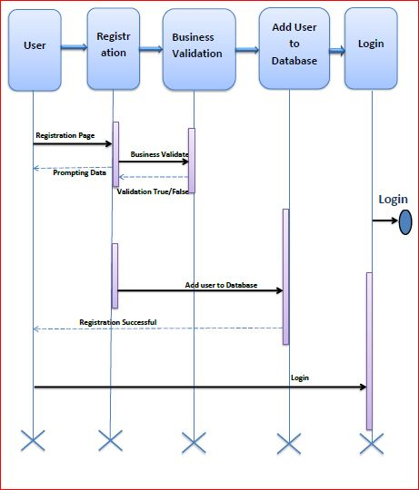

Functional Requirement
. Login Page checks the authentication of the user and based on his role, directs the user to the respective page. User will provided with Add Patient, Details, Regulation and Search regulation pages and the same user will allowed to see Diagnosis Reports and patient vital parameters reports

UI Validations
- User Id and Password fields are mandatory.
- Invalid User Id and / or password should not allow the user to get into the system

UI Controls
# | UI Component | Type | Name | Details
1 | User Id | Label | label_For_User_Id
2 | User | Text field | Textfield_user | To enter username
3 | password | Label | Label_for_password
4 | password | Text field | Textfield_password | To enter password

UI Methods Definition
Method Name | Parameter | Details
SignButton_Click | object sender, EventArgs e | Allows the user to login into the portal and register the patient.
ResetButton_Click | object sender, EventArgs e | Clears the details entered by the user.
HomeButton_Click | object sender, EventArgs e | Loads the Homepage after registration is done successfully.
RegisterButton_Click | object sender, EventArgs e | Allows the user to insert the User personal details
ResetButton_Click | object sender, EventArgs e | Resets all fields given by user.
Page_Load | None | None
BMICalculator_Button_Click | object sender, EventArgs e | Allows the user to calculate the BMI of Patient
GlucometerButton_Click | object sender, EventArgs e | Allows the user to calculate the Blood Glucose Level of Patient
BloodCountButton_Click | object sender, EventArgs e | Allows the user to calculate the Blood Count Details of Patient
BMI_SubmitButton_Click | object sender, EventArgs e | To store the details to the database
Glucometer_SubmitButton_Click | object sender, EventArgs e | To store the details to the database
BloodCount_Submit_Button_Click | object sender, EventArgs e | Stores all the details in the database

UI Design
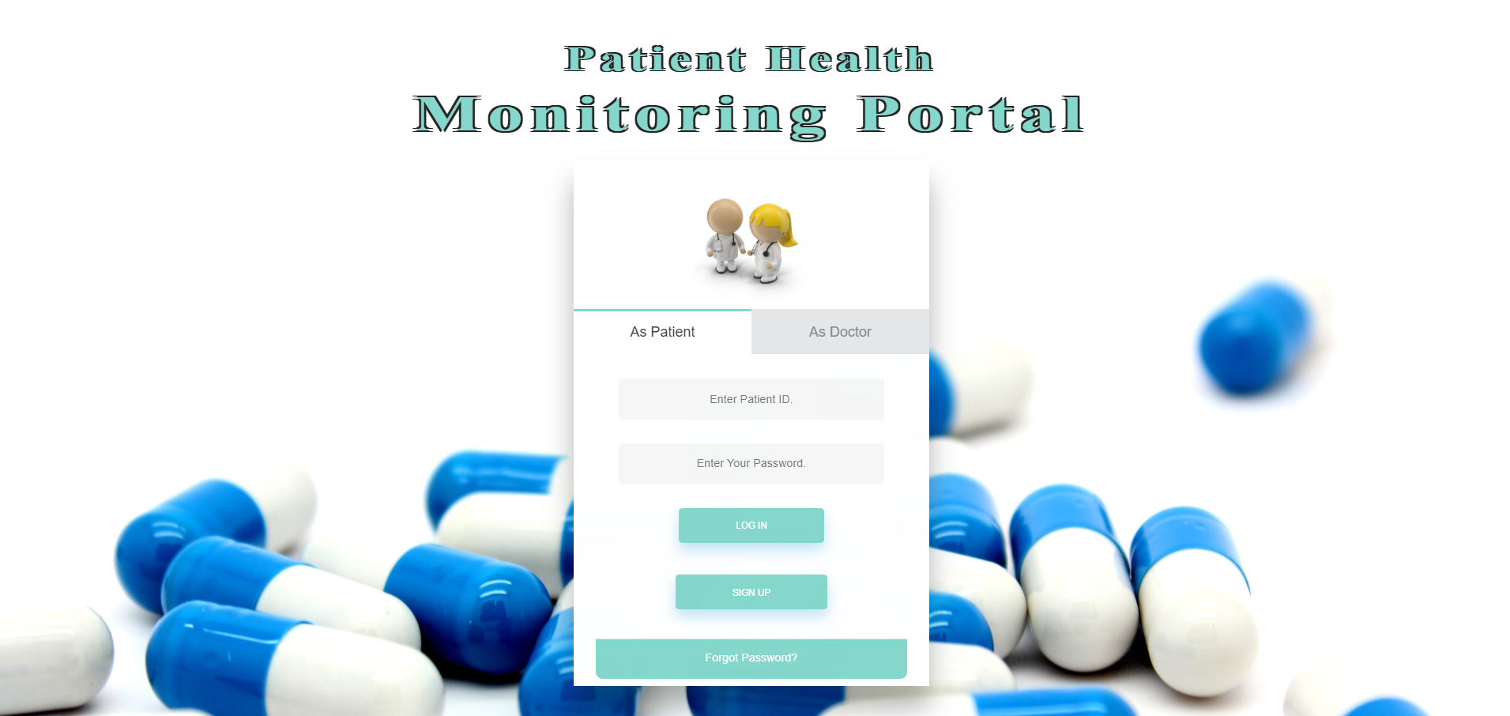

Database Design

Data Model

The following is a schematic view of the database design
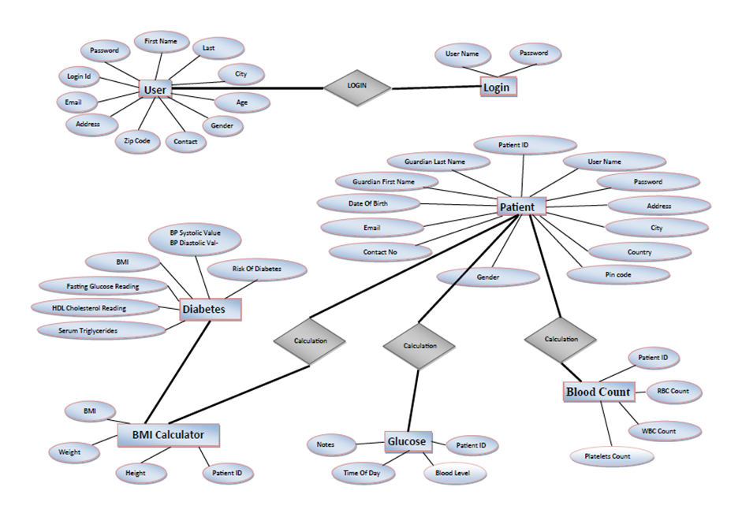

Tables Structure
User Registration:
Column Name | Data Type | Length | Nulls
Login Id | varchar | 50 | N
Password | varchar | 50 | N
First Name | varchar | 50 | N
Last Name | varchar | 50 | N
Age | int | 5 | N
Gender | varchar | 10 | N
Contact Number | varchar | 10 | N
Email | varchar | 50 | N
Address | varchar | 50 | N
Zipcode | varchar | 50 | N
City | varchar | 50 | N
State | varchar | 50 | N

User login:
Column Name | Data Type | Length | Nulls
User Id | varchar | 50 | N
Password | narchar | 50 | N

Patient Registration:
Column Name | Data Type | Length | Nulls
Patient Id | varchar | 10 | N
Username | varchar | 50 | N
Password | varchar | 50 | N
Date Of Birth | date |  | N
Email Address | varchar | 50 | Y
Contact Number | varchar | 10 | N
Address | varchar | 250 | N
City | varchar | 50 | N
Country | varchar | 50 | N
Gender | varchar | 10 | N

Change Log
Please note that this table needs to be maintained even if a Configuration Management tool is used.
Version Number | Changes made
V1.0 | <First version>
V1.1 | <If the change details are not explicitly documented in the table below, reference should be provided here>
V1.1 | Page no | Changed by | Effective date | Changes effected
V1.2 | <If the change details are not explicitly documented in the table below, reference should be provided here>
V1.2 | Page no | Changed by | Effective date | Changes effected

